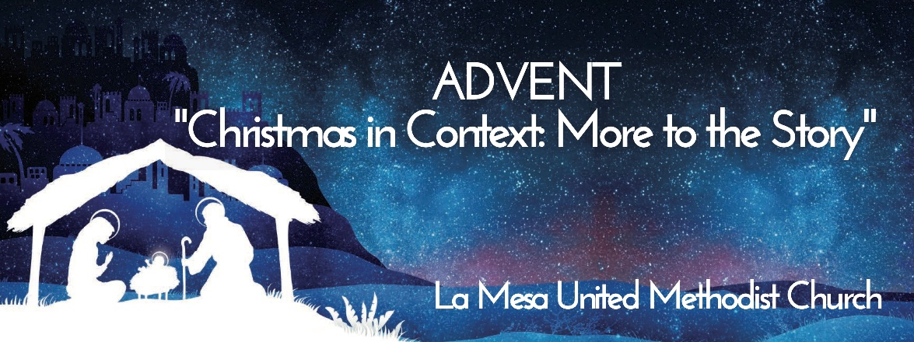

La Mesa First United Methodist Church
Second Sunday of Advent
December 4, 2022

Opening Rev. Christian DeMent

Prelude Lob sei dem allmaechtigen Gott J. S. Bach
Michael Lawrence, organ

~Acolytes Kira Cothran & Jack DeMent ~
.

Welcome & Greeting Rev. Christian DeMent

Announcements Mary Earnest

Advent Hymn O Come, O Come, Emmanuel UMH 211
V. 3 & Refrain

Advent Candle Lighting – Hope Don, Julie & Jack DeMent

Hymn of Response Come Thou Long Expected Jesus UMH 196
V. 1,2

Children’s Moment Rev. Christian DeMent

Anthem Carol of the Shepherd Boy J. Martin
Chancel Choir
Michael Lawrence, Interim Director

Prayers of the Community Rev. Christian DeMent

Invitation To Offering Andres de los Reyes

Offertory The First Noel Trad. English Carol
Stephanie Draper, Soloist

Offertory Prayer Andres de los Reyes

Scripture Matthew 2:1-12 Andres de los Reyes

Sermon Christmas in Context: Who is the Real King?
Rev. Christian DeMent

Communion

Hymn Sing We Noel UMH 237
V. 1, 4 & 5

Benediction Rev. Christian DeMent

Postlude Der Tag der is so Freudenreich M. Dupre
Michael Lawrence, organ

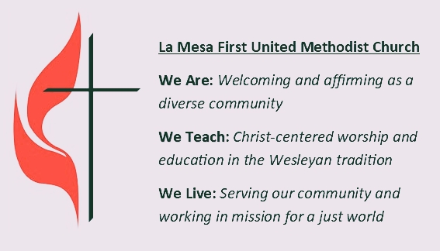

La Mesa First United Methodist Church • 4690 Palm Avenue, La Mesa, CA 91941
www.lamesaumc.com • 619-466-4163 • lamesaumc@lamesaumc.com
Rev. Christian DeMent, Pastor • Michael Lawrence, Interim Music Director
• Javier Piñón, AV Tech • Omar de los Reyes, Paul McDaniel, Sound Techs
•Stephanie Draper, Fiery Spirit Children’s Choir Director
• Michael Lawrence, Organist/Accompanist
CCLI License #1840524, Streaming License #20692262

Thank you for worshiping with us this morning!
Next week, please join us again in person at 9:30 am; on Facebook or YouTube for the Livestream; or either of those channels to view a recording on your own schedule.
Check our e-newsletter for more information or go to lamesaumc.com.

Scan for current newsletter and giving page

